The seven “I AM” sayings of Jesus
1) Bread – sustenance and satisfaction
And Jesus said to them, "I am the bread of life. He who comes to Me shall never hunger, and he who believes in Me shall never thirst.” John 6:35
- Bread is the most important staple food of humans from the prehistoric time. Baked bread is integral to human health with plenty of major nutrients, antioxidants and vitamins. Jesus is the sustenance of life.
- Jesus replied, “Anyone who drinks this water will soon become thirsty again. But those who drink the water I give will never be thirsty again. It becomes a fresh, bubbling spring within them, giving them eternal life. John 4:13-14

2) Light – true sight, truth, understanding and direction
“I am the light of the world; he who fallows Me shall not walk in the darkness, but shall have the light of life.” John 8:12
- The way of the righteous is like the first gleam of dawn, which shines ever brighter until the full light of day. But the way of the wicked is like total darkness. They have no idea what they are stumbling over. Proverbs 4:18-19

3) Gate – Jesus is the only entry point to the Father and all spiritual blessings
“I am the gate; if anyone enters through Me, he shall be saved, and shall go in and out, and find pasture.” John 10:9, 10:1-10
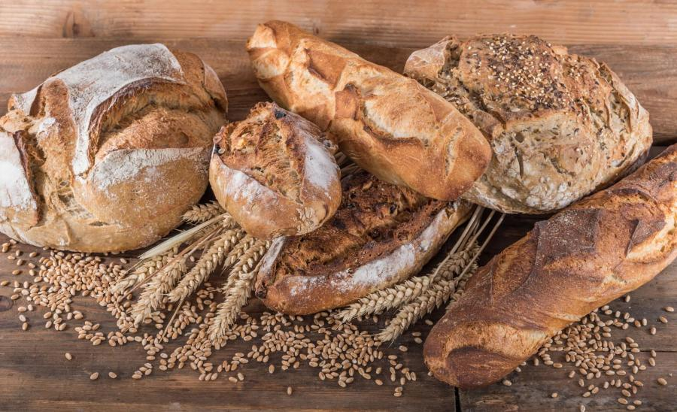
- You can enter God’s Kingdom only through the narrow gate. The highway to hell is broad, and its gate is wide for the many who choose that way. But the gateway to life is very narrow and the road is difficult, and only a few ever find it. Matthew 7:13-14

4) Good Shepherd – He only wants what is best, we must listen for His voice and follow Him
“I am the good shepherd; the good shepherd lays down His life for His sheep.” John 10:11
- The Lord is my Shepherd – Psalm 23
- For the Lamb on the throne will be their Shepherd. He will lead them to springs of life-giving water. And God will wipe every tear from their eyes. Revelation 7:17

5) Resurrection and Life
Jesus said to her, "I am the resurrection and the life. He who believes in Me, though he may die, he shall live. And whoever lives and believes in Me shall never die. Do you believe this?" John 11:25-26
- I shall not die, but live – Jn.3:16, Ps.118:17
- But even Moses showed in the burning bush passage that the dead are raised, when he called the Lord ‘the God of Abraham, the God of Isaac, and the God of Jacob.’ For He is not the God of the dead but of the living, for all live to Him. Luke 20:37-38

6) The Way, Truth, Life – Jesus is the only remedy God has provided for man’s sin problem. He is the only way to eternal life. This is the truth of God’s Word. “I am the way, and the truth, and the life; no one comes to the Father, but through Me.” John 14:6
- Pilate therefore said to Him, “Are You a king then?” Jesus answered, “You say rightly that I am a king. For this cause I was born, and for this cause I have come into the world, that I should bear witness to the truth. Everyone who is of the truth hears My voice.” Pilate said to Him, “What is truth?” And when he had said this, he went out again to the Jews, and said to them, “I find no fault in Him at all.” John 18:37-38

7) True vine – true fruitfulness in life only comes through an intimate relationship with Christ
"I am the vine, you are the branches. He who abides in Me, and I in him, bears much fruit; for without Me you can do nothing.” John 15:5
- The divinity of Jesus Christ is further illustrated in John 8:58. Jesus said, “Truly, Truly, I say to you, before Abraham was born, I am”, which means that Jesus existed before His human life on earth.

