Abide in the vine

John chapter 15:1-11
What does it mean to “abide in Christ?” It means having a relationship, being obedient and submitting to His pruning.

THINGS NEEDED TO BE FRUITFUL: JOHN 15:1-11
1) You must submit to pruning – Hebrews 12:10, Whoever loves instruction loves knowledge, but he who hates correction is stupid. Proverbs 12:1
- God’s motives are always to do us good in the end – Deuteronomy 8:16, 10:12-13
- God demands fruit – Luke 13:6-9, John 15:16, Proverbs 29:1, And even now the ax is laid to the root of the trees. Therefore every tree which does not bear good fruit is cut down and thrown into the fire. Matthew 3:10

2) You must maintain an abiding union with Christ and his word – Psalm 1:2-4
This Book of the Law shall not depart from your mouth, but you shall meditate in it day and night, that you may observe to do according to all that is written in it. For then you will make your way prosperous, and then you will have good success. Joshua 1:8

THE RESULTS OF FRUITFULNESS
1. Christ like character – Gal.5:22-23
2. Answered prayer – Jn.15:7, 16
3. God is glorified – Jn.15:8, Rom.3:23
4. We experience greater joy – Jn.15:11, 16:24

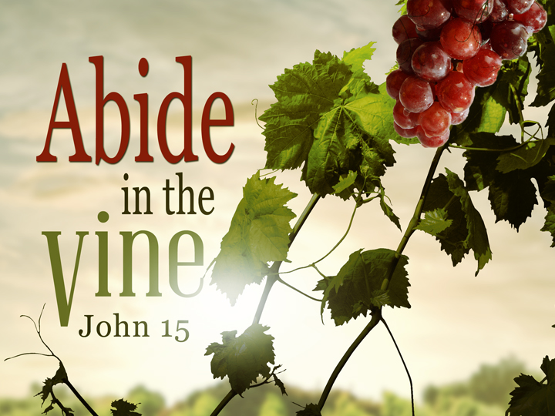

encouragement to believe in miracles
Matthew 19:26, Mark 10:27, Mark 9:23
But Jesus looked at them and said to them, “With men this is impossible, but with God all things are possible.” Matthew 19:26

Jesus said to him, “If you can believe, all things are possible to him who believes.” Mark 9:23

But Jesus looked at them and said, “With men it is impossible, but not with God; for with God all things are possible.” Mark 10:27

The giver of all things
Matthew 7:11, James 1:17, Psalm 84:11
If you then, being evil, know how to give good gifts to your children, how much more will your Father who is in heaven give good things to those who ask Him! Matthew 7:11

Every good gift and every perfect gift is from above, and comes down from the Father of lights, with whom there is no variation or shadow of turning. James 1:17

For the Lord God is a sun and shield; The Lord will give grace and glory; No good thing will He withhold From those who walk uprightly. Psalms 84:11

