Jesus is the greatest gift of all
For unto us a Child is born, unto us a Son is given; And the government will be upon His shoulder. And His name will be called Wonderful, Counselor, Mighty God, Everlasting Father, Prince of Peace. Of the increase of His government and peace there will be no end, Upon the throne of David and over His kingdom, to order it and establish it with judgment and justice from that time forward, even forever. The zeal of the Lord of hosts will perform this. Isaiah 9:6-7

Matthew, Chapters one and two
1) Prophecy fulfilled – Matthew 1:18-25
Matthew shows more prophetic fulfilment than any other gospel. Matthew’s focus was to prove to the Jews that Jesus was the Messiah.
- Jesus was the prophesied seed of Abraham and son of David
- Jesus was born of a virgin; He was the Son of God
- Jesus was born in the prophesied birthplace of Bethlehem

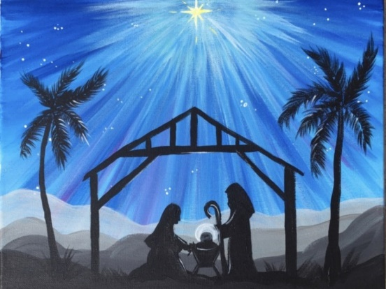
2) Wise men from the East – Matthew 2:1-10
The magi were eastern astrologers and knew the prophecies from Daniel who was chief of the Magi during the Babylonian captivity.
- Their visit shows the kingly identity of Jesus
- It affirms the Bethlehem origin of the Messiah
- It emphasizes the Gentile faith and worship of the Messiah in contrast to the hostility of the Jews

3) The three gifts of the wise men – Matthew 2:11
The three gifts of the wise men have prophetic significance.
- Gold – King, divine
- Frankincense – Priest, intercession
- Myrrh – Prophet, sacrifice

4) God speaks to Joseph in dreams – Matthew 2:13-23
Joseph is like his name’s sake in the book of Genesis. Both of them receive revelation through dreams - Job 33:14-18

5) Jesus is the greatest gift of all
For God so loved the world that He gave His only begotten Son, that whoever believes in Him should not perish but have everlasting life. John 3:16

But as many as received Him, to them He gave the right to become children of God, to those who believe in His name. John 1:12

